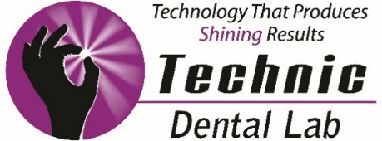

Technic Dental Lab and Nobel Biocare Present:
Optimal Implant Esthetics – A Predictable Roadmap
Brent Ludens, DDS

Date: April 13, 2018 Time: 8:00am – 3:00pm
DoubleTree Hotel Chicago ~ 1909 Spring Road Oak Brook, IL 60523
(Breakfast and Plated Lunch included)
6 AGD CE Units Fee: $95 Please RSVP to Jamie at 219-902-5081 or 708-479-1212 or jamie@technicdentallab.com

Dentistry has witnessed tremendous advancement in both esthetic and implant dentistry. Advancement in clinical and surgical materials, technology, techniques, implant designs and laboratory support has created patient care that exceeds most expectations. This has brought with it a significant responsibility for dentists to acquire the necessary knowledge to deliver esthetic and implant treatment at the highest level.

This program is designed to reinforce the basic concepts of esthetic and implant dentistry. The real world of clinical practice too often presents the clinician with cases that are not ideal esthetic or implant cases. Some present challenges in failed or retreatment needs; prosthetic design and material selection can cause confusion. Utilizing real case studies, this course delivers a detailed approach to diagnosing, treatment planning, case presentation, professional communication, material selection, and delivery of treatment.

An extensive course handout will provide detailed information on the necessary materials, equipment, instrumentation, technology, and techniques required. Step-by-step protocols, flow charts, and checklist will give each participant a clinical reference that is easy to follow and geared for the real full-time general dentist.

Course content:

- Introduction to dental implants
- Restorative indications for maxillary anterior dental implants
- Decisions in implant dentistry for maxillary anterior implant(s)
- Extraction with immediate implant placement
- Delayed placement
- Provisional restorations
- Management of soft tissue
- Developing an emergence profile
- Developing or maintaining the papilla
- Immediate provisionalization – indications
- Delayed provisionalization – indications
- Staff considerations and responsibilities
- Practice management
- Communication - developing your implant team
  - With the patient
  - Between the surgeon and restorative dentist
  - Between the restorative dentist and the laboratory

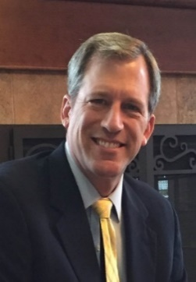
About the speaker, Brent Ludens, DDS
Dr. Brent Ludens maintains a full-time practice limited to prosthodontics, emphasizing cosmetic, reconstructive, and implant dentistry. For over 15 years, he has lectured nationally on dental implants and prosthodontics. He is a member of the American College of Prosthodontists, the American Dental Association, and the Iowa Dental Association.

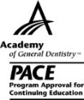

Technic Dental Laboratory, Inc. is designated as an Approved PACE Program Provider by the Academy of General Dentistry. The formal continuing education programs of this program
provider are accepted by AGD for Fellowship, Mastership and membership maintenance credit. Approval does not imply acceptance by a state or provincial board of dentistry or AGD
endorsement. The current term of approval extends from 7/1/2015 to 6/30/2018. Provider ID#324387.

TECHNIC DENTAL LAB ~ 11555 West 183rd Place ~ Orland Park, IL 60467 ~ 708-479-1212 ~ www.technicdentallab.com

