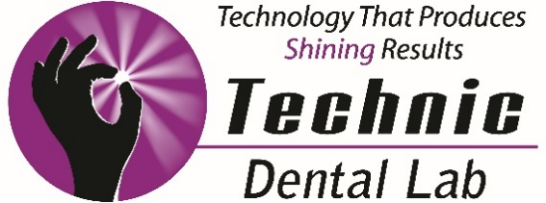

11555 West 183rd Place ● Orland Park, IL 60467 ● 708.479.1212
Hygiene and the All-On-4 Technique
With Courtney Beth Anderson, RDH

Date: March 7, 2018 Time: 6:00pm – 8:30pm
Fee: $50 CE: 3 AGD Units
Location: TBD
Please RSVP to Jamie at 219-902-5081 or jamie@technicdentallab.com
_____________________________________________________________________________
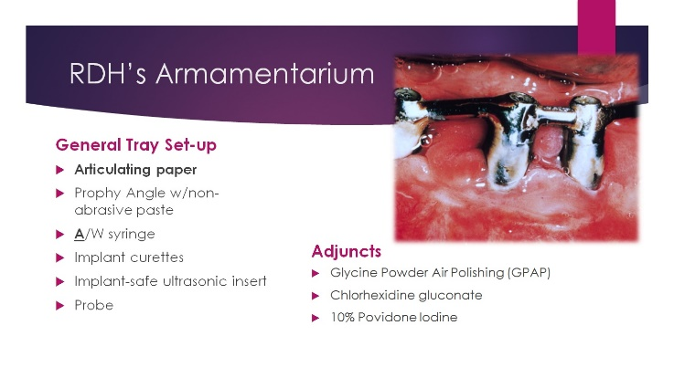
We will review hygiene protocol for your
All-On-4 patients, beginning day of
surgery, through the final restoration
and beyond.

Bring your hygienist!

Frequently asked questions regarding hygiene:
- Do I have to come back for cleanings ever again?
- Do I have to brush my teeth ever again?
- What am I supposed to use to keep my new teeth clean?
- Will the teeth ever come out of my mouth again?
- How do I clean under the hybrid?

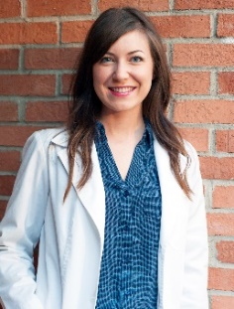
Our Speaker: Courtney Beth Anderson, RDH
Courtney was born and raised in the northwest suburbs of Chicago. Her dental interest started at a young age and to assist in her direction she completed the Dental Assisting Program at Elgin Community College in 2002. From there she surgically assisted in Oral and Periodontal Surgery for 7 years before deciding to apply to the Dental Hygiene Program at Harper College.
Graduating in 2009, Courtney knew that she had found her passion, connecting dental hygiene with long-term dental implant maintenance. The level of professionalism, continuing education and extensive patient care that is demonstrated in this field leads to a fulfilling career.

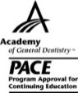
Technic Dental Laboratory, Inc. is designated as an Approved PACE Program Provider by the Academy of General Dentistry. The formal continuing education programs of this program provider are accepted by AGD for Fellowship, Mastership and membership maintenance credit. Approval does not imply acceptance by a state or provincial board of dentistry or AGD endorsement. The current term of approval extends from 7/1/2015 to 6/30/2018.

